* **Remote repository is already created, and you want to clone it (section#1)**

1. Consider we have already created git repository (e.g. <https://github.com/MakarandBhoir/LearningGitRepository1.git>)
2. Open cmd in any folder. Clone the repository you have created.

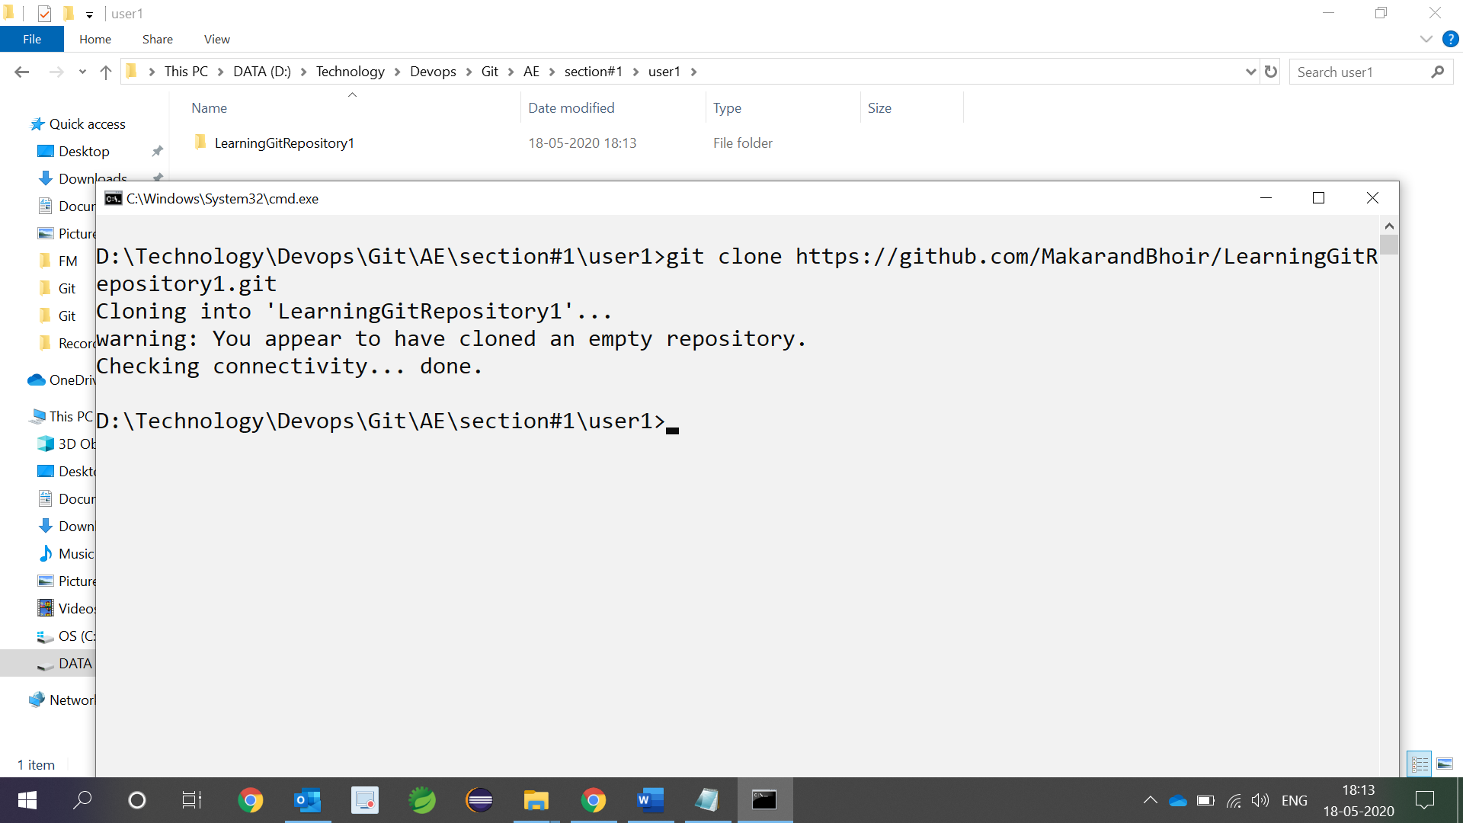

1. Add any file to working repository (folder). We are adding ReadMe.txt to LearningGitRepository1 folder

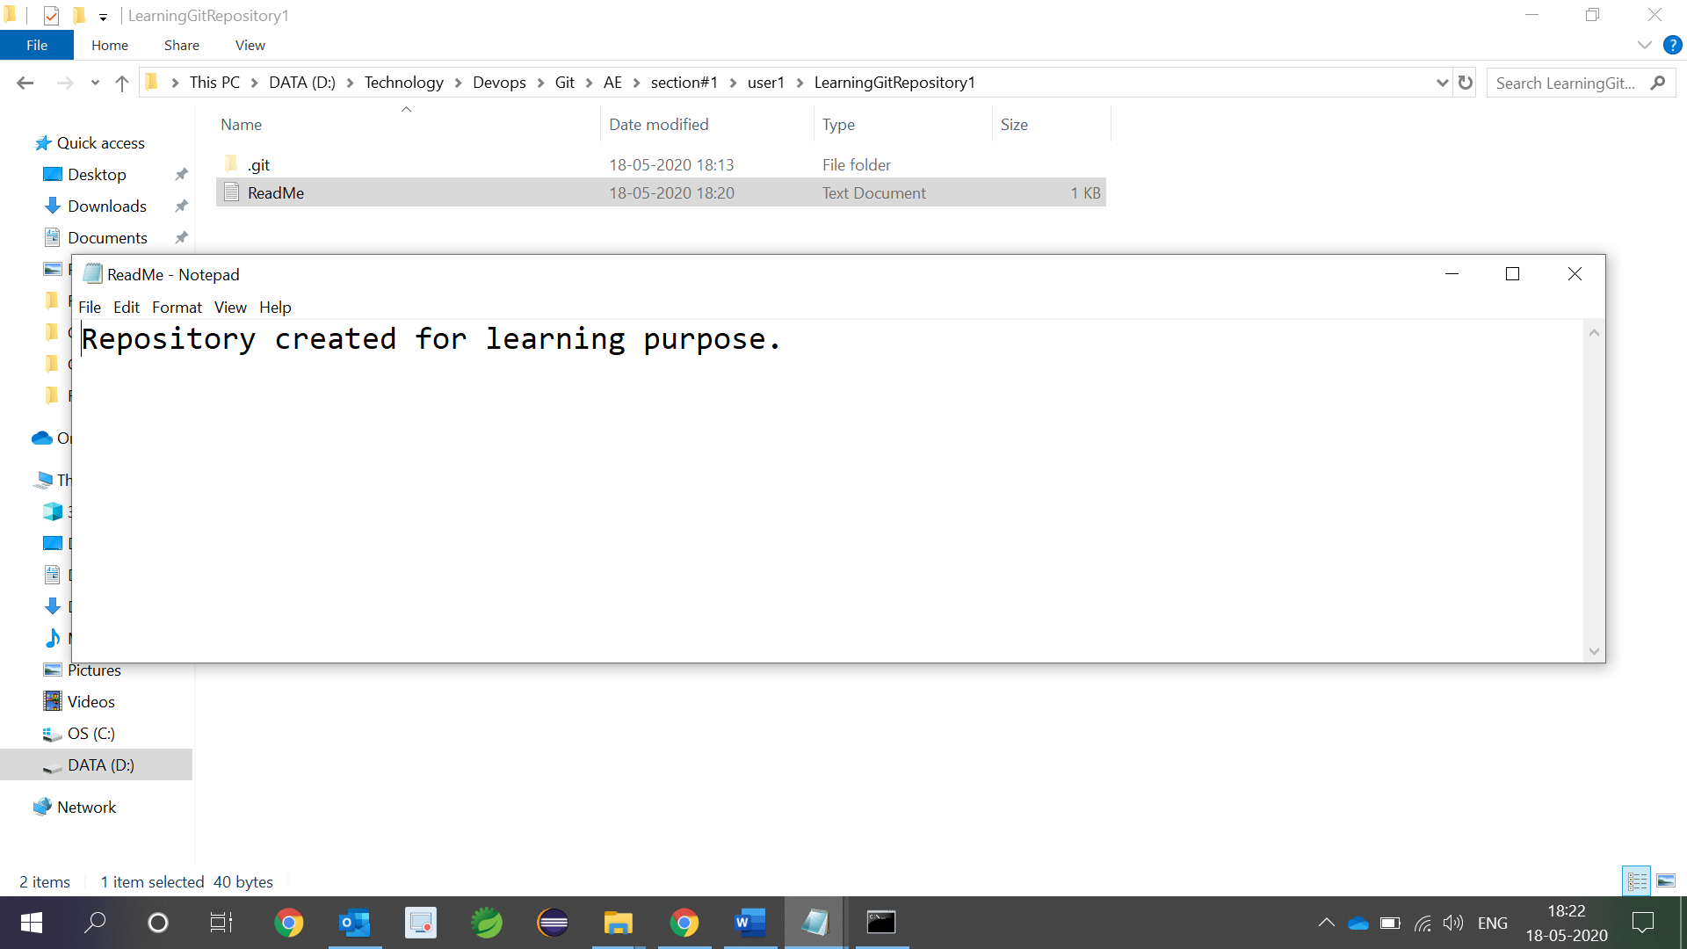

1. Check whether any untrack file present in working tree (in this case we have one ReadMe.txt file)

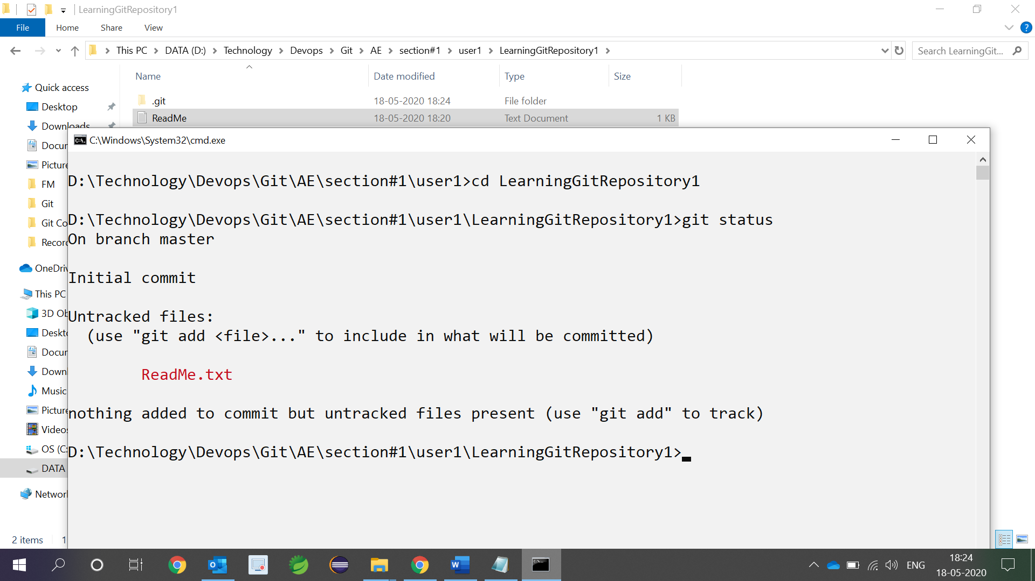

1. Add the files to staging area using following command (git add filename)

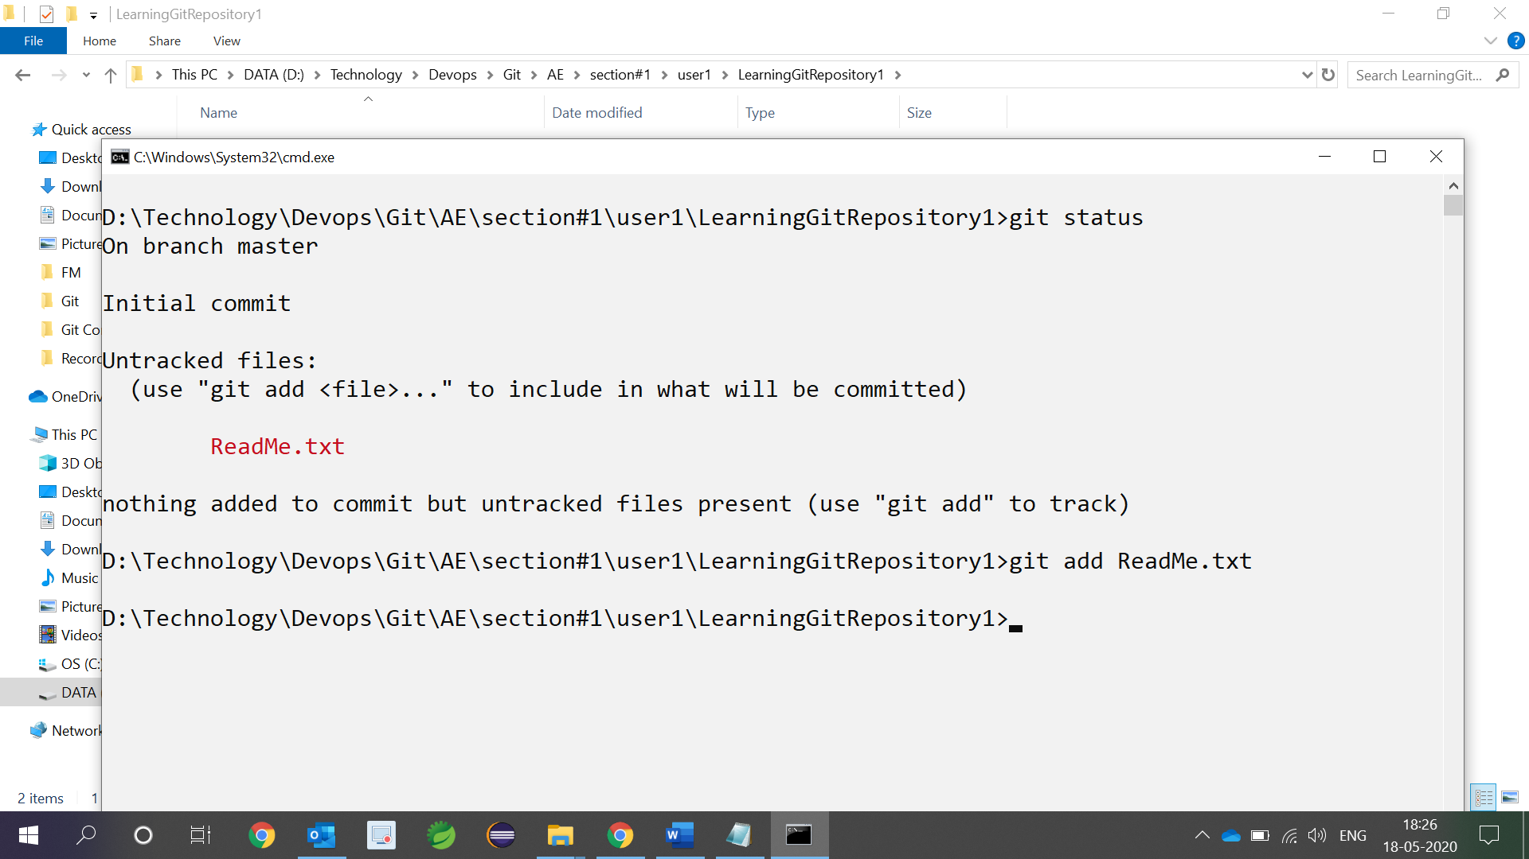

1. To save the changes to local repository use (git commit -m “message”)

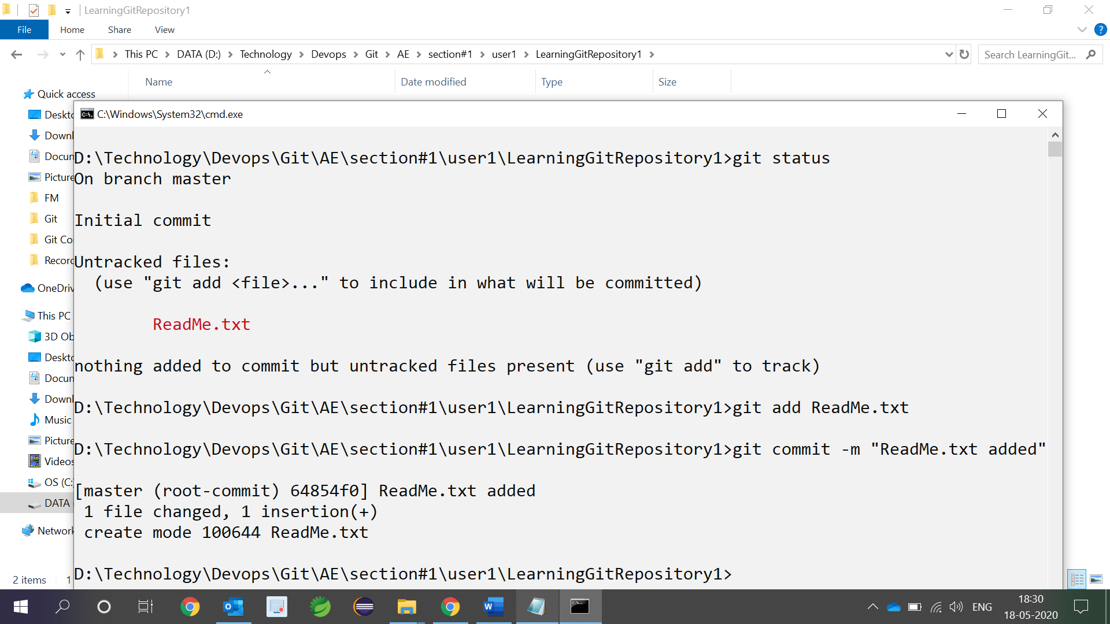

1. To save the changes to remote repository use (git push). First time you may have to enter git credential

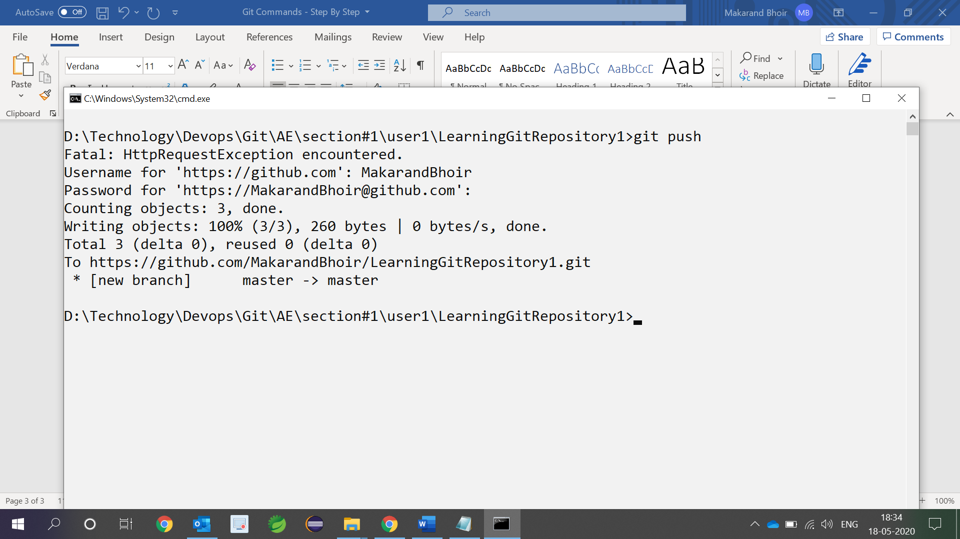

1. Go to github and confirm the change that we have made

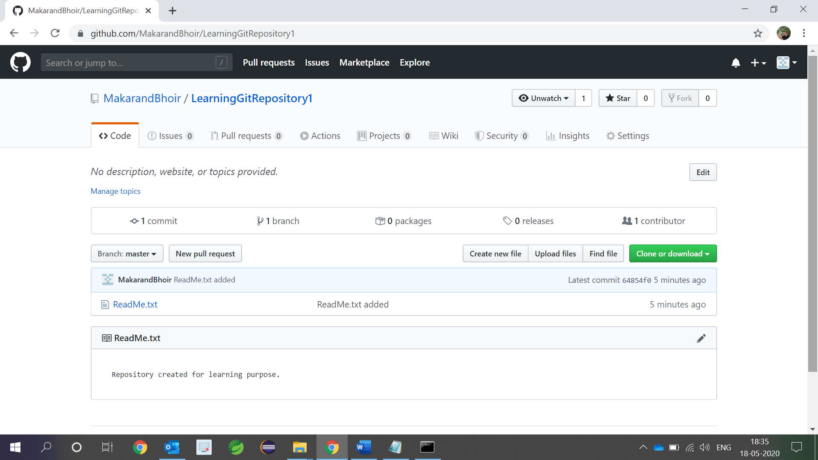

* **Create first local repository and then push the contents to remote repository (section#2)**

1. Create empty local repository in any folder

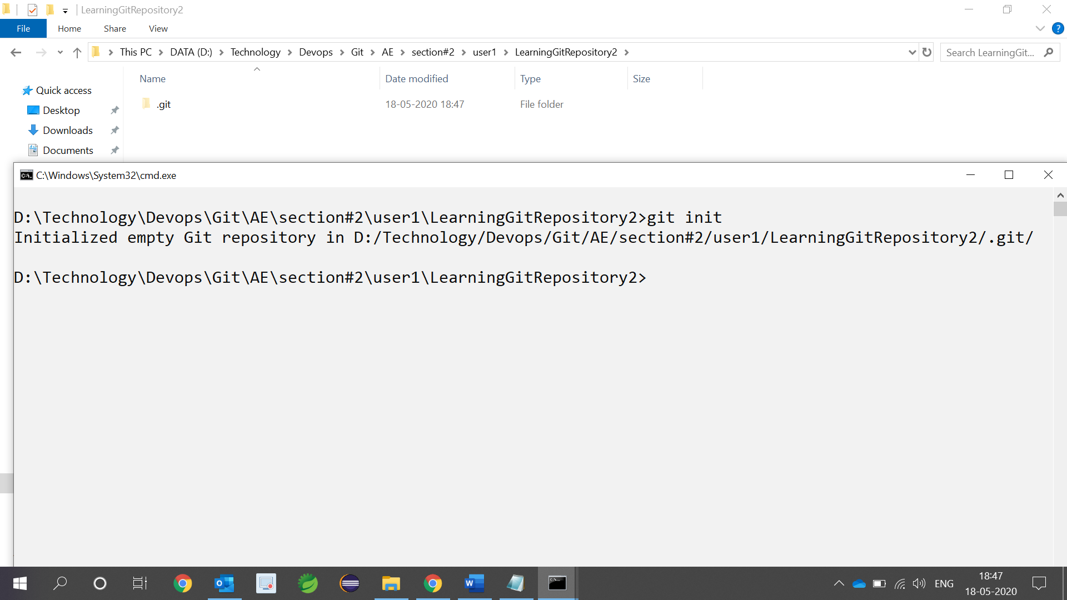

1. Add ReadMe.txt file to LearningGitRepository2 folder

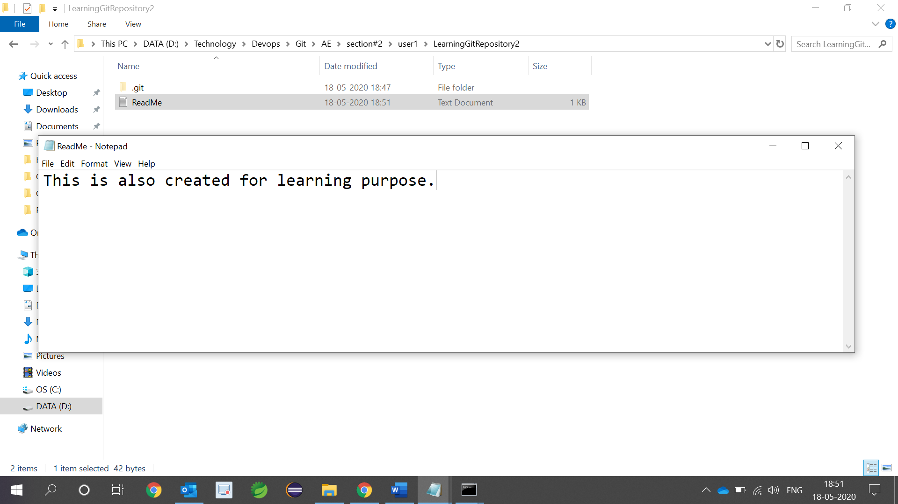

1. Add file to staging area using (git add .)

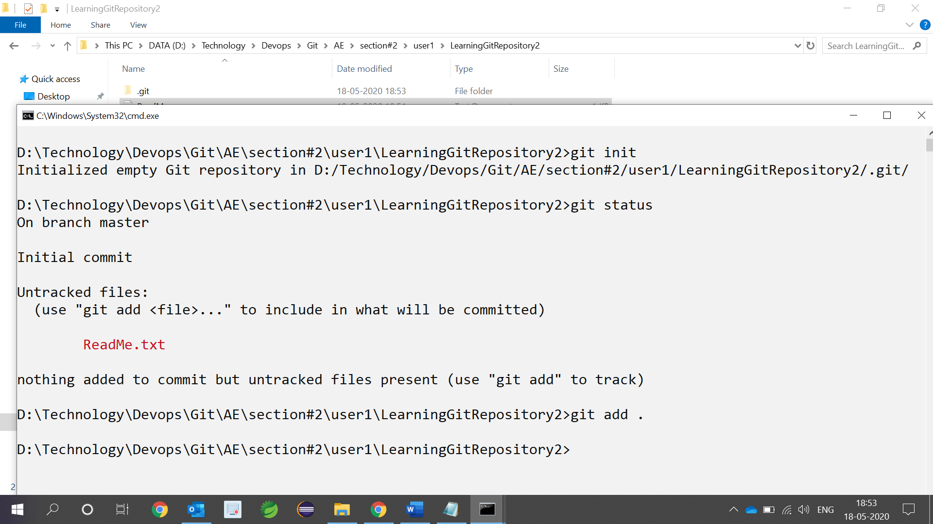

1. Save the file(s) to local repository using (git commit -m “message”)

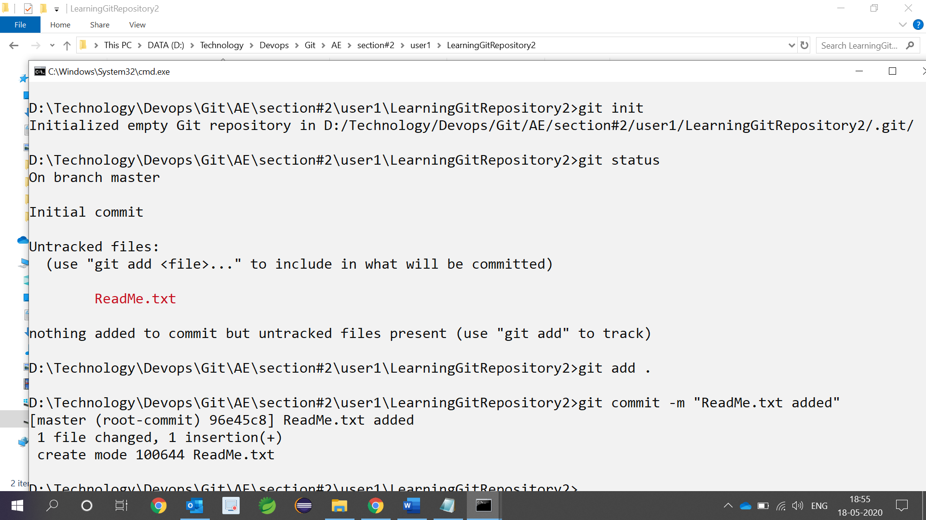

1. Create git remote repository ( <http://github.com> ). Log In and create one repository

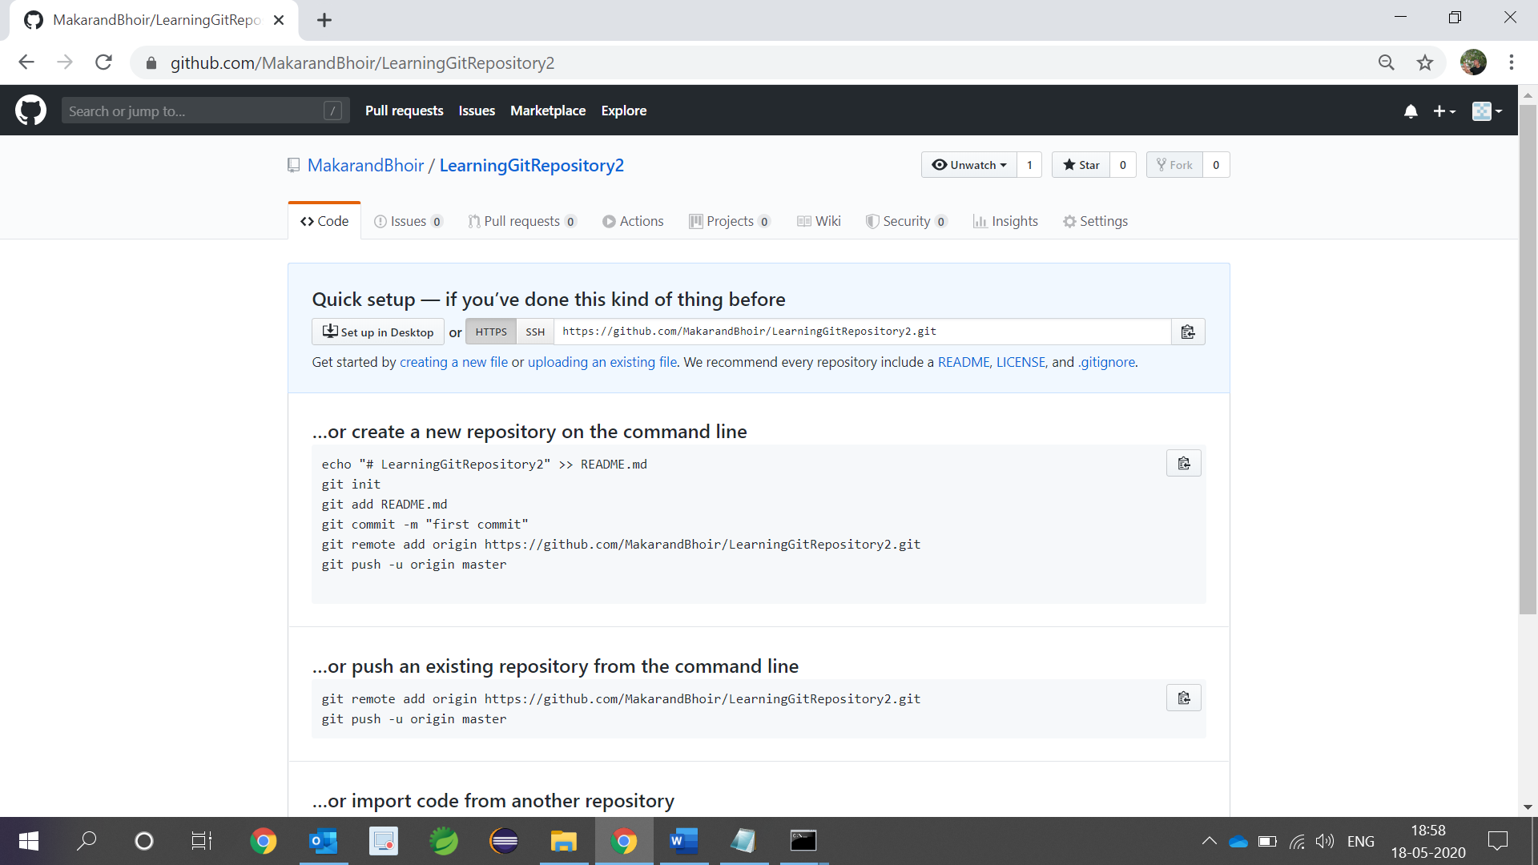

1. Set push url to <https://github.com/MakarandBhoir/LearningGitRepository2.git>.

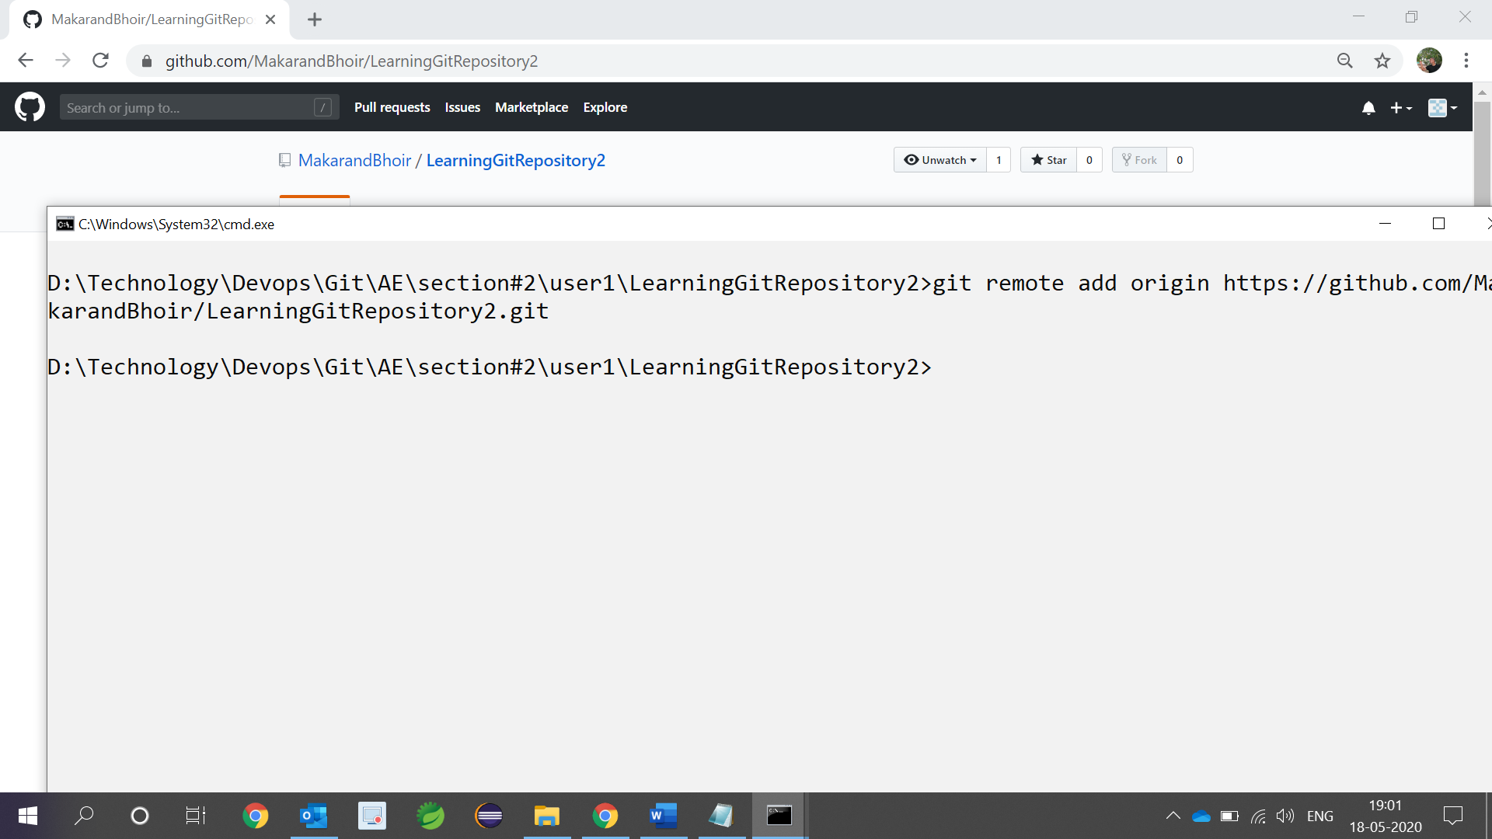

1. Push the files to remote repository using (git push)

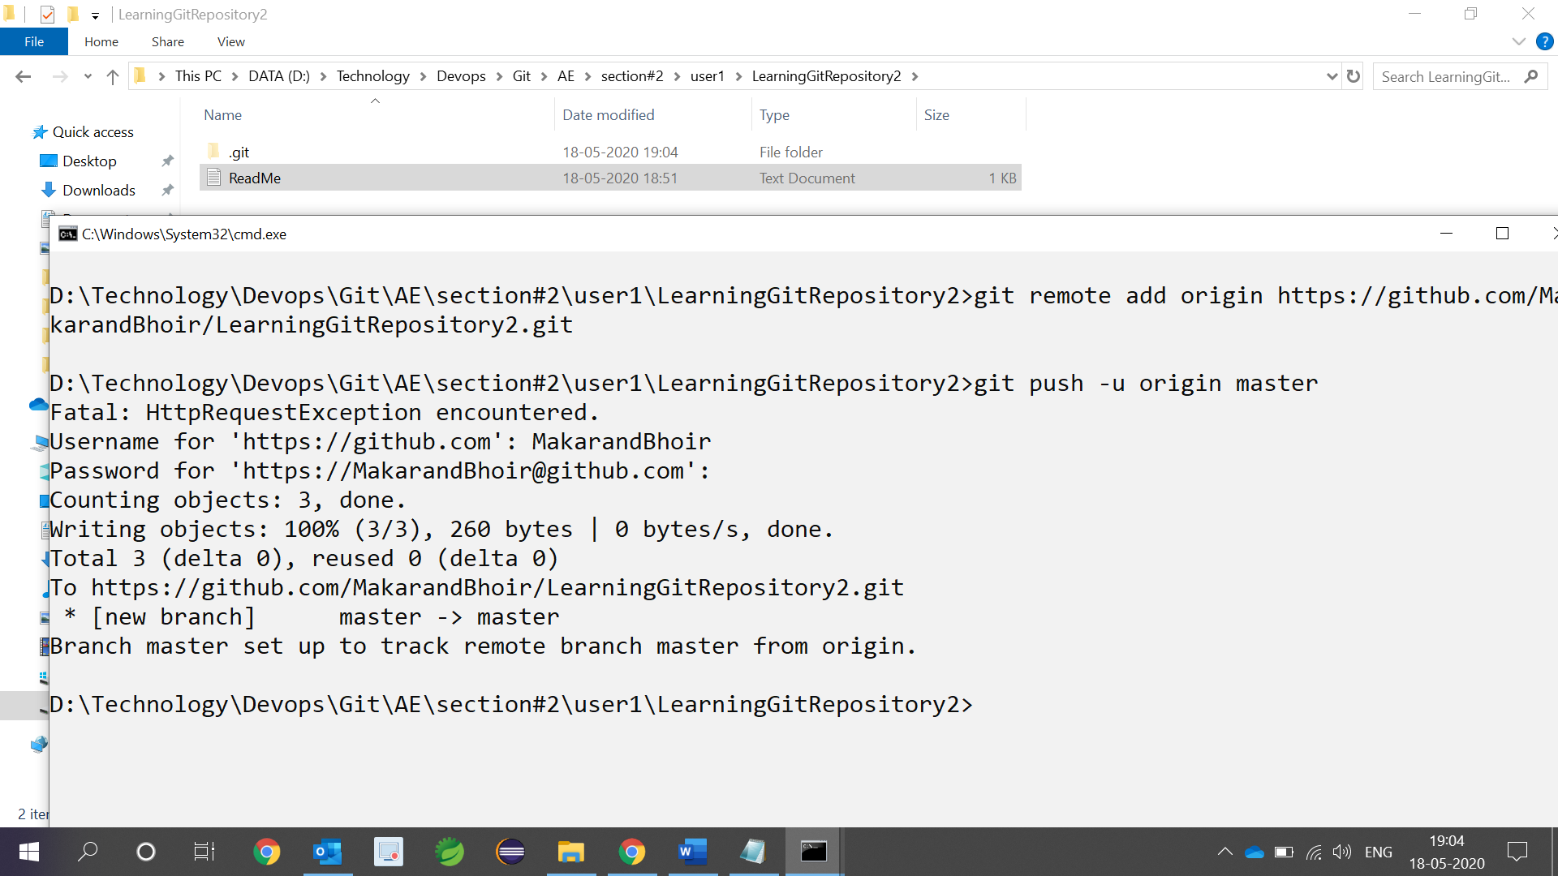

1. Confirm the contents of github remote repository

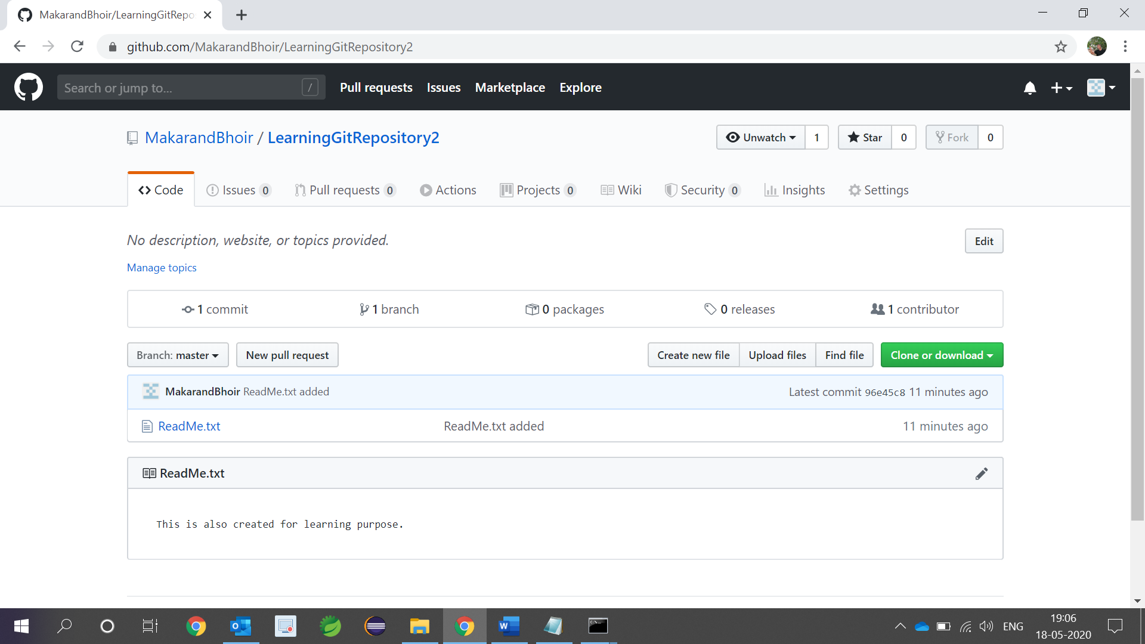

* **Working with branch**

1. Create new branch called as new_branch (git branch new_branch)

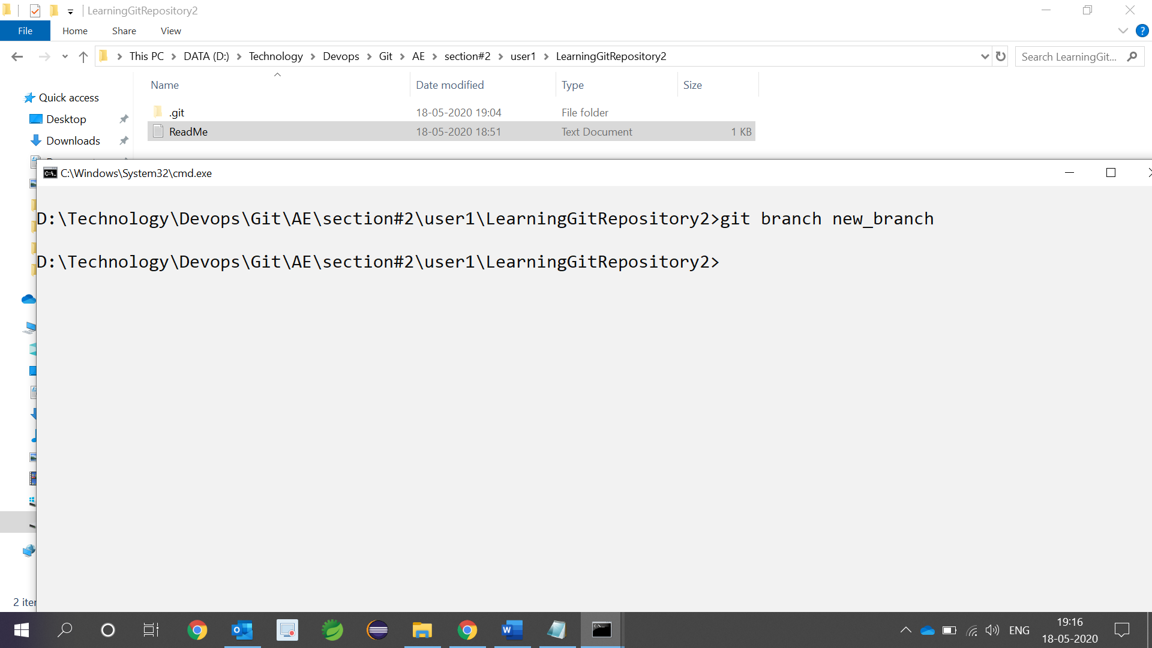

1. Checkout new_branch using (git checkout new_branch)

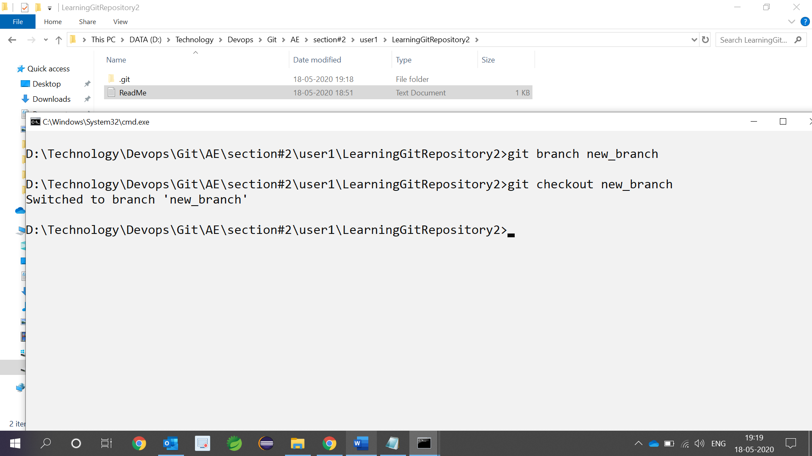

1. Add one new file to new_branch

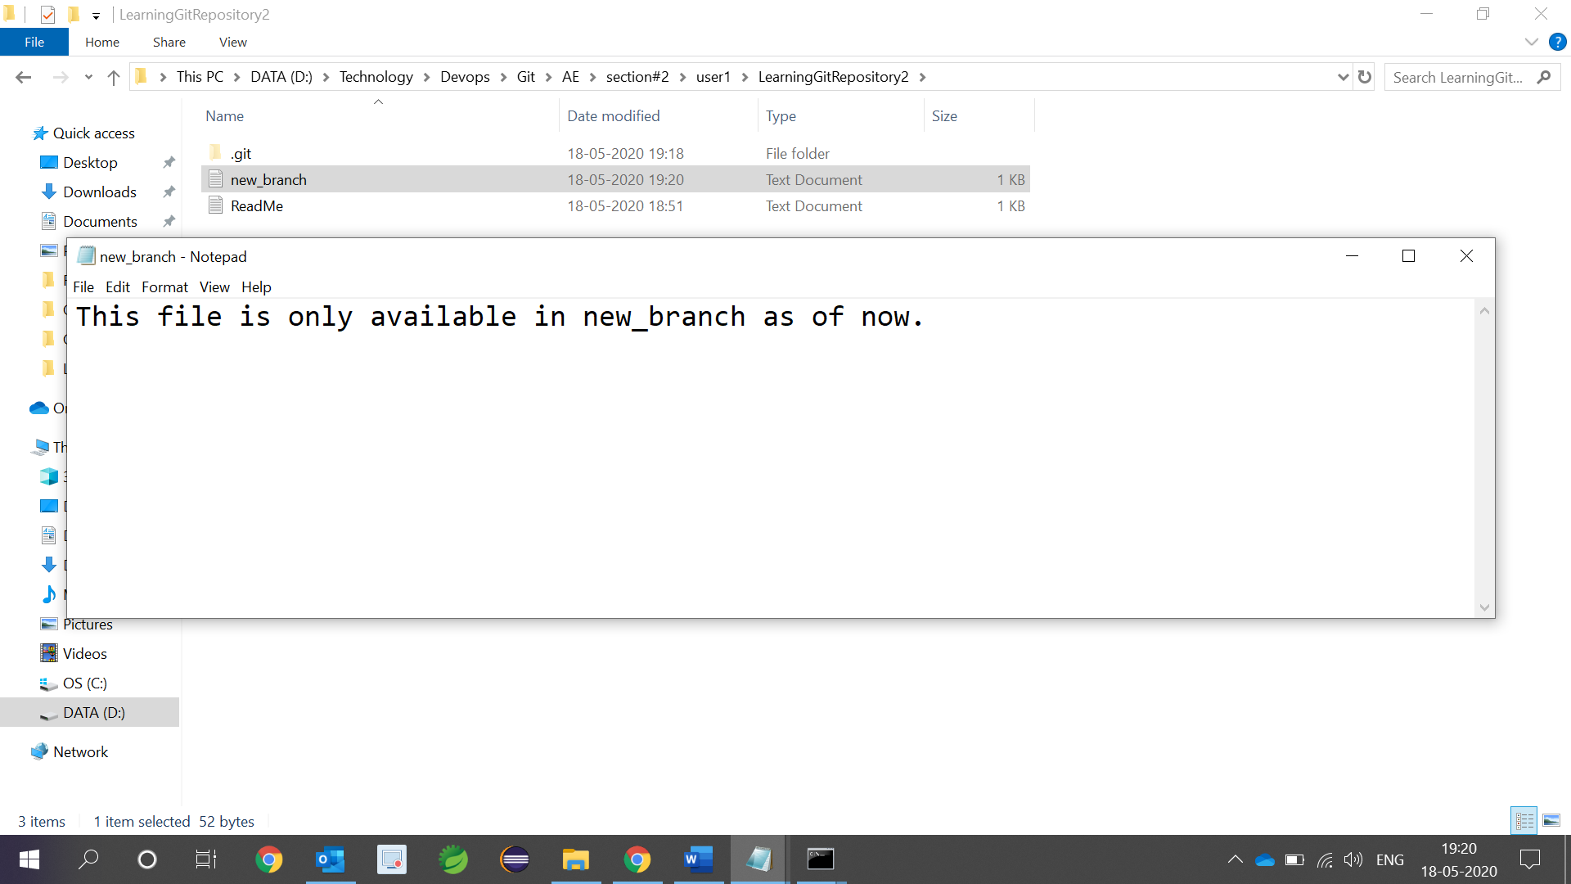

1. Add the file to staging area and local repository

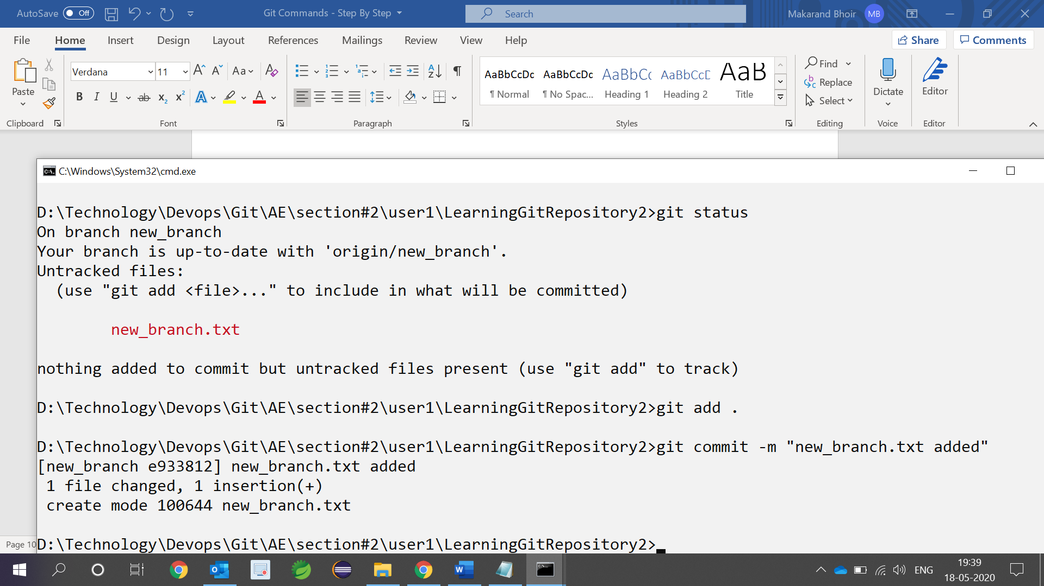

1. Push the branch to remote (github) location, so new_branch will be available using (git push -u origin new_branch)

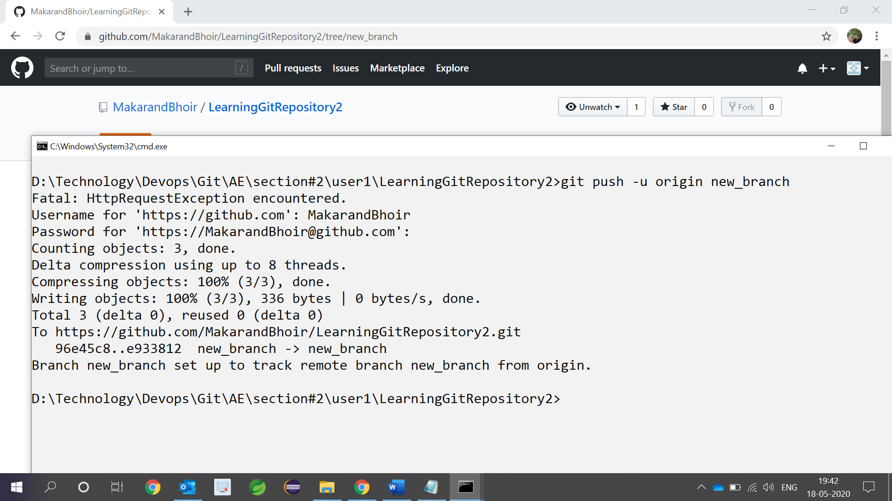

1. Confirm branch is added to github

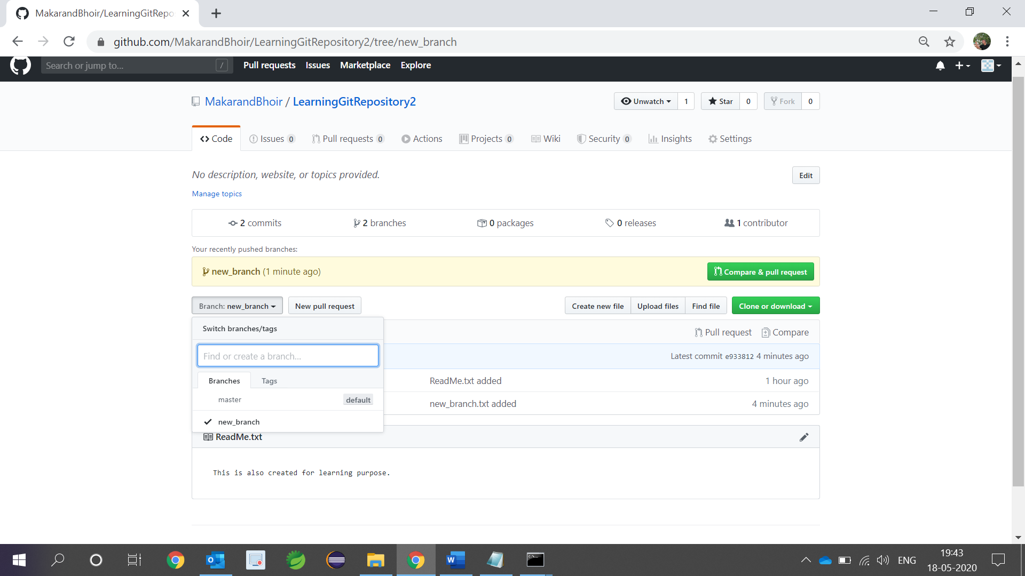

1. This point our active branch is new_branch and there are two files present

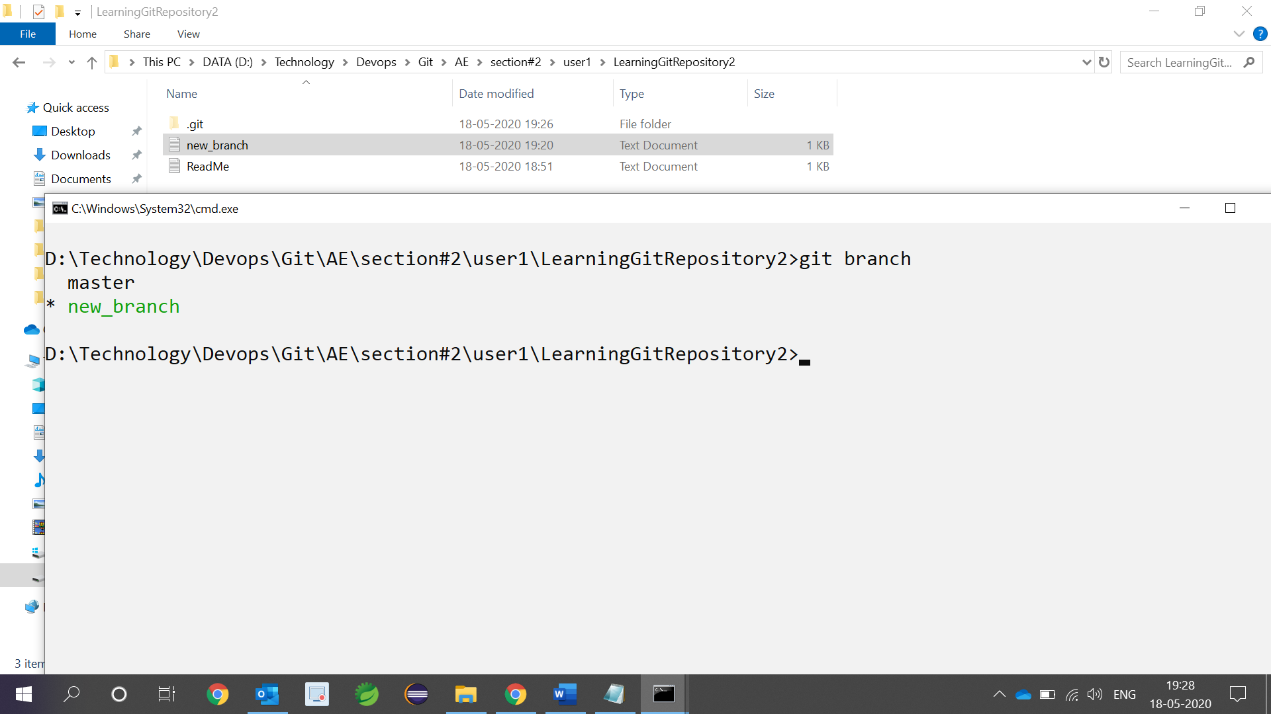

1. Switch to the master branch using (git checkout master) and you should see only ReadMe.txt

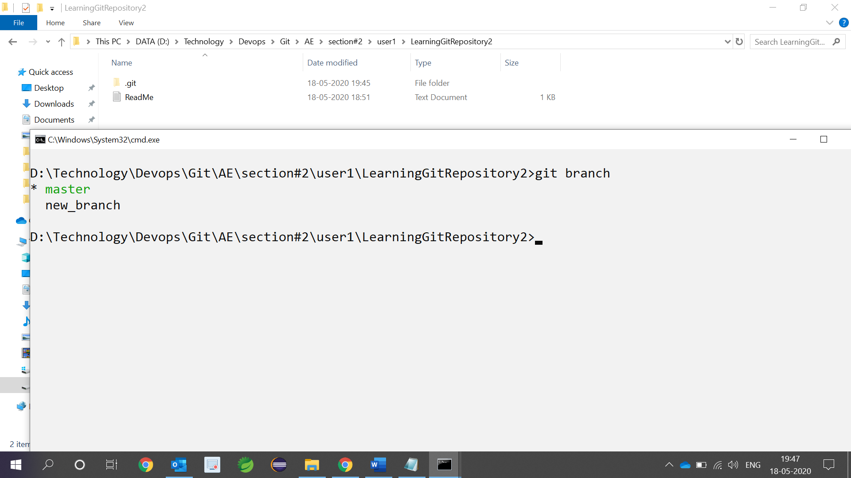

1. Merge new_branch to the master branch (the effect will happen in local repository) and you should see both file in local folder but not in the remote.

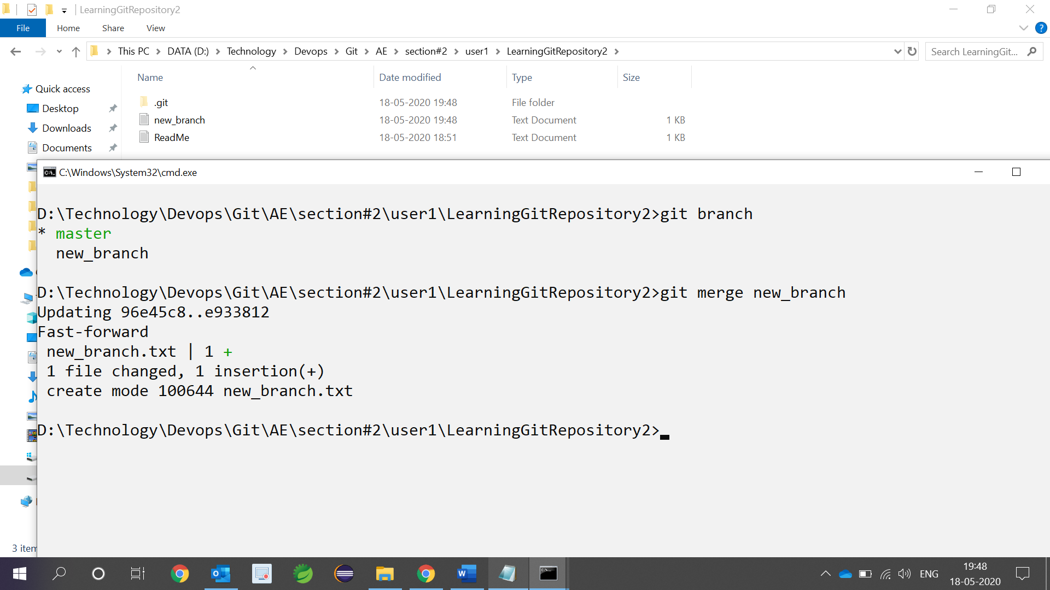

1. Push branch to remote i.e. merge it with master branch

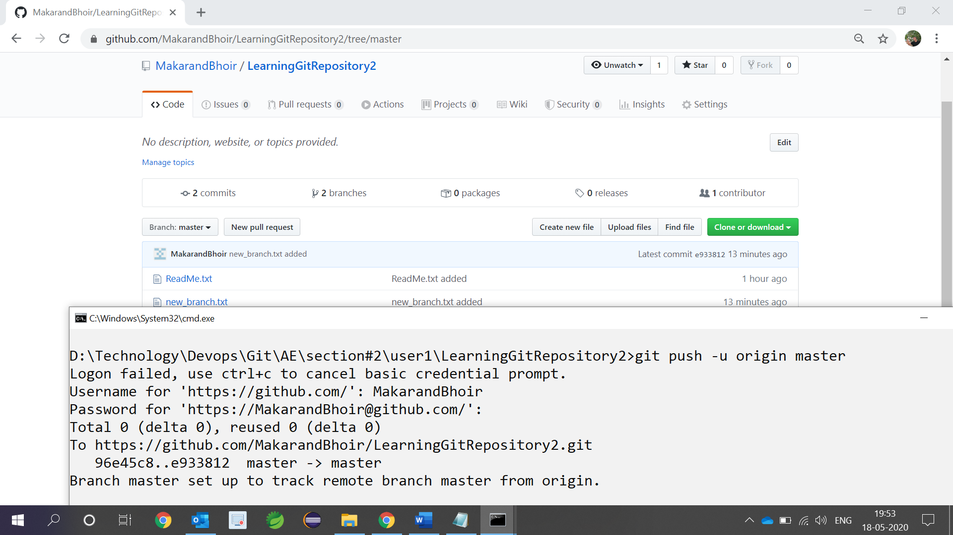

1. Delete branch new_branch from local

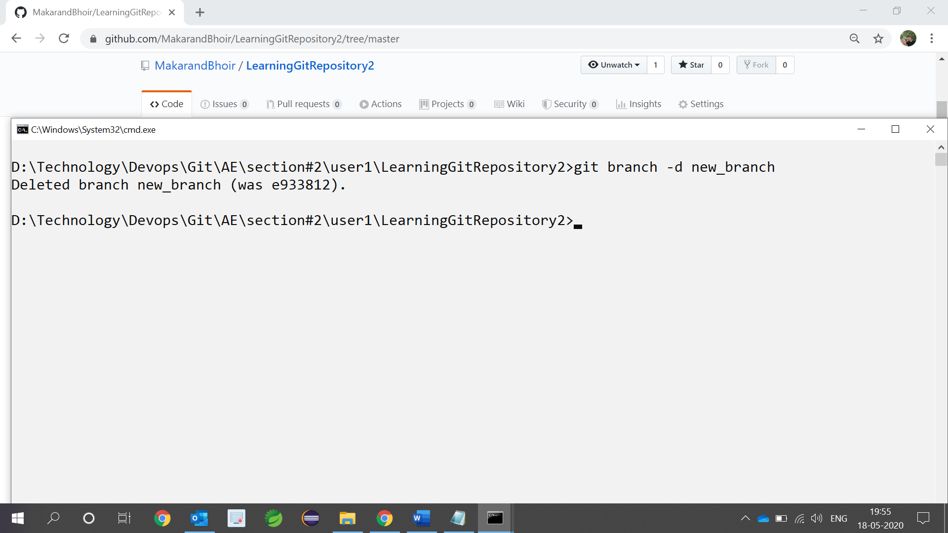

1. Delete branch new_branch from remote

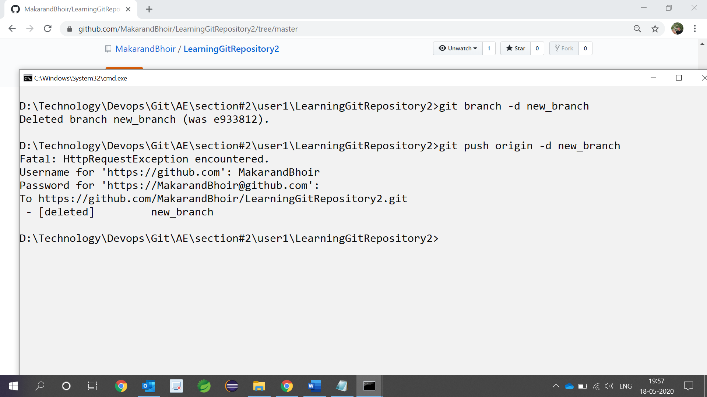

1. Confirm remote repository

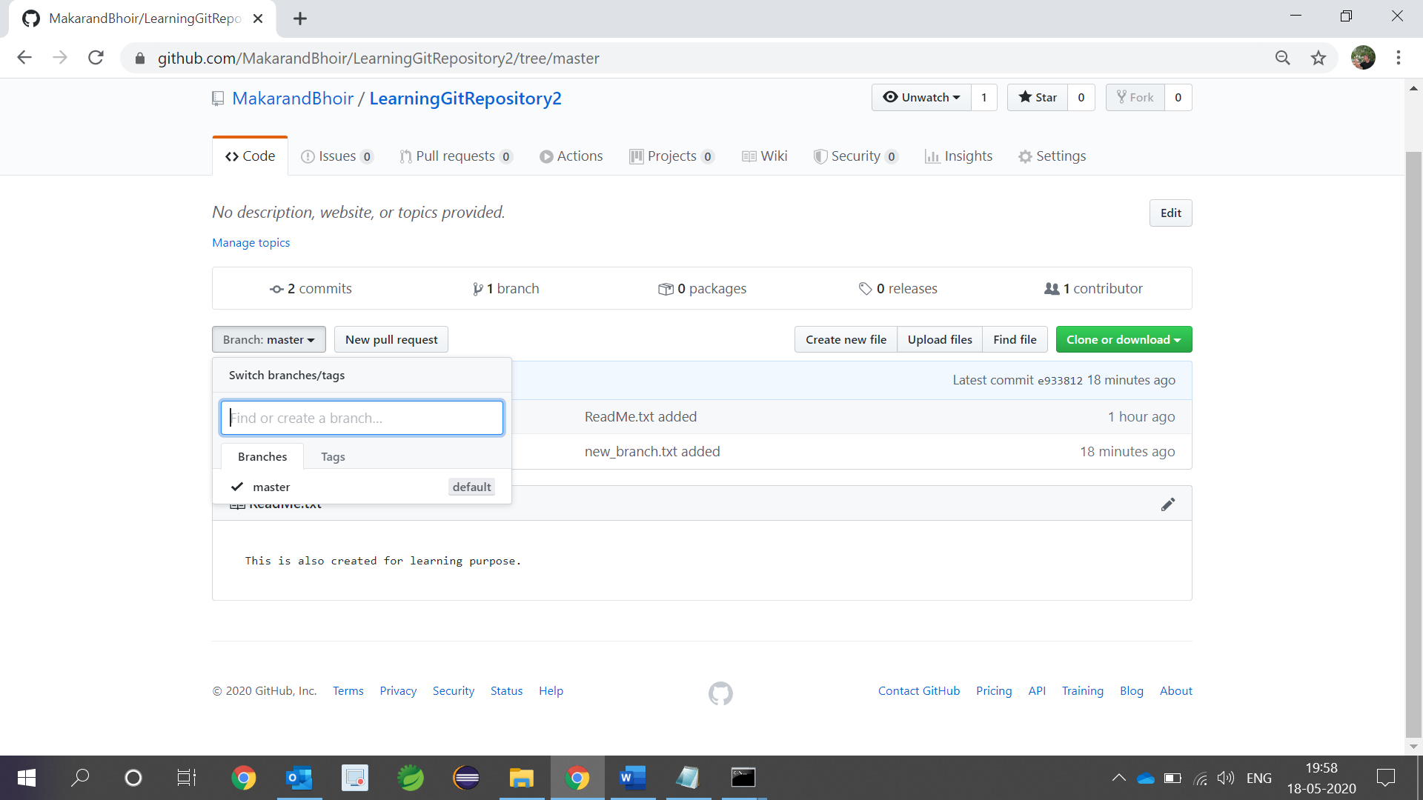

* **Adding file(s) to more than one repository (section#3)**

1. We have 2 repositories LearningGitRepository1 & LearningGitRepository2

URL 1:- <https://github.com/MakarandBhoir/LearningGitRepository1.git>

URL 2:- <https://github.com/MakarandBhoir/LearningGitRepository2.git>

1. Create new folder multiuser under section#3 and execute git init

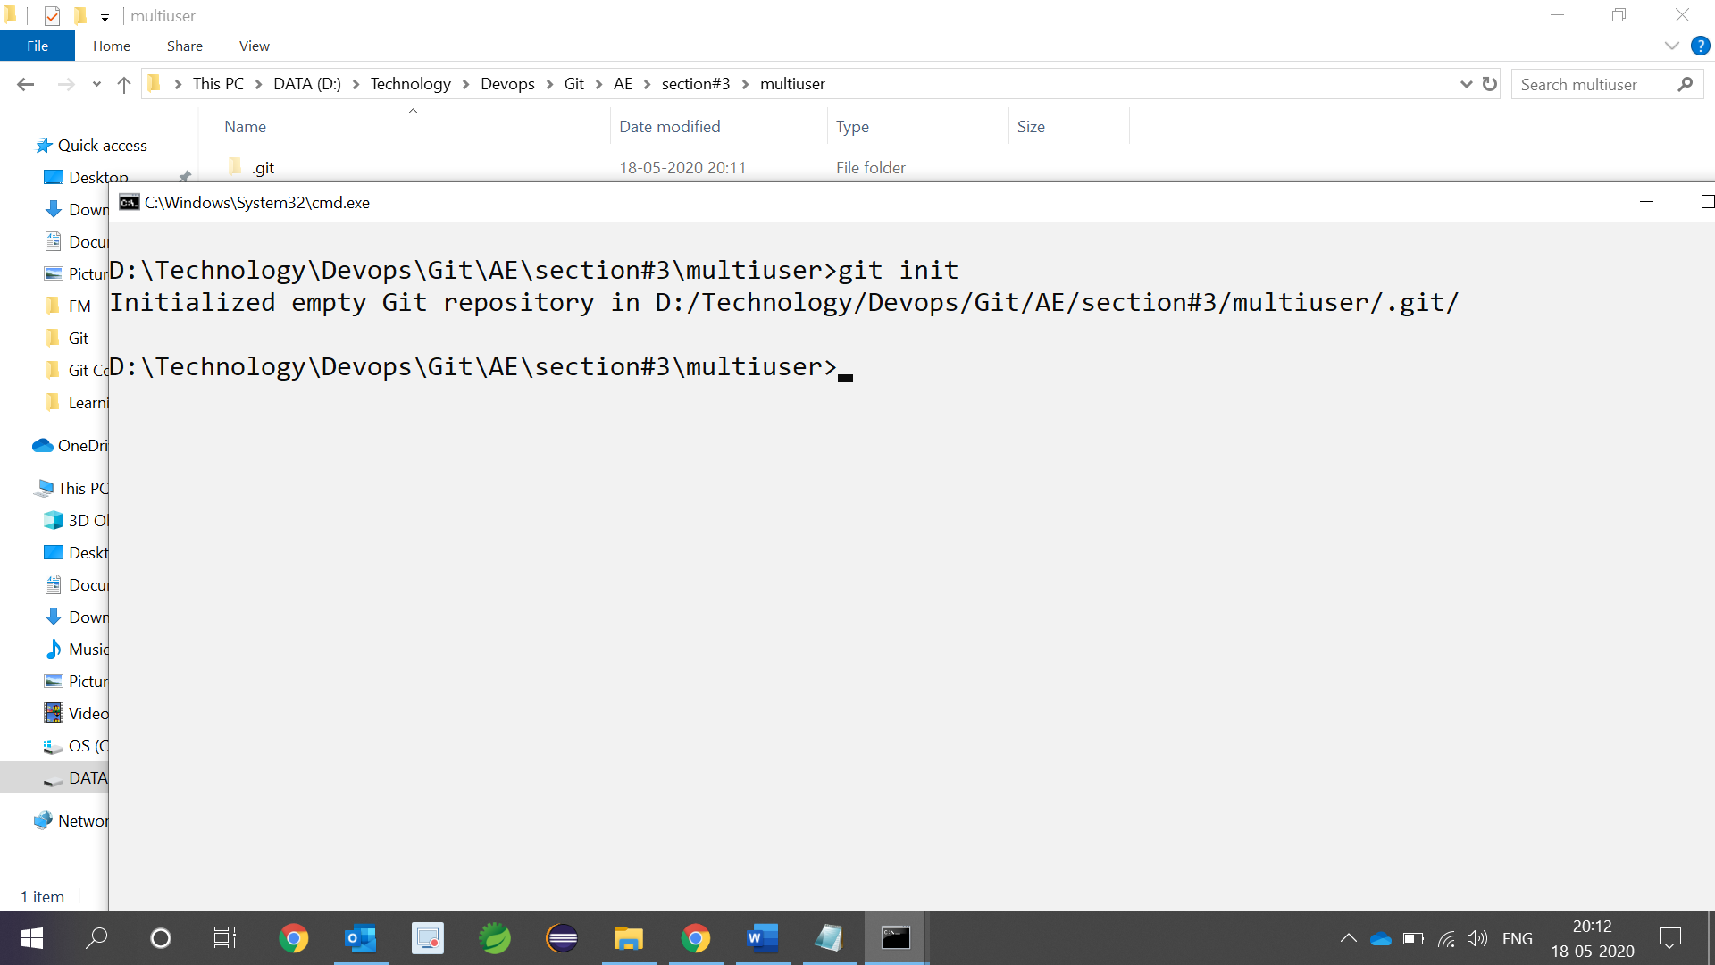

1. Adding first repo URL to variable (all)

git remote add all <https://github.com/MakarandBhoir/LearningGitRepository1.git>

1. Register LearningGitRepository1 URL as push URL

git remote set-url --add --push all <https://github.com/MakarandBhoir/LearningGitRepository1.git>

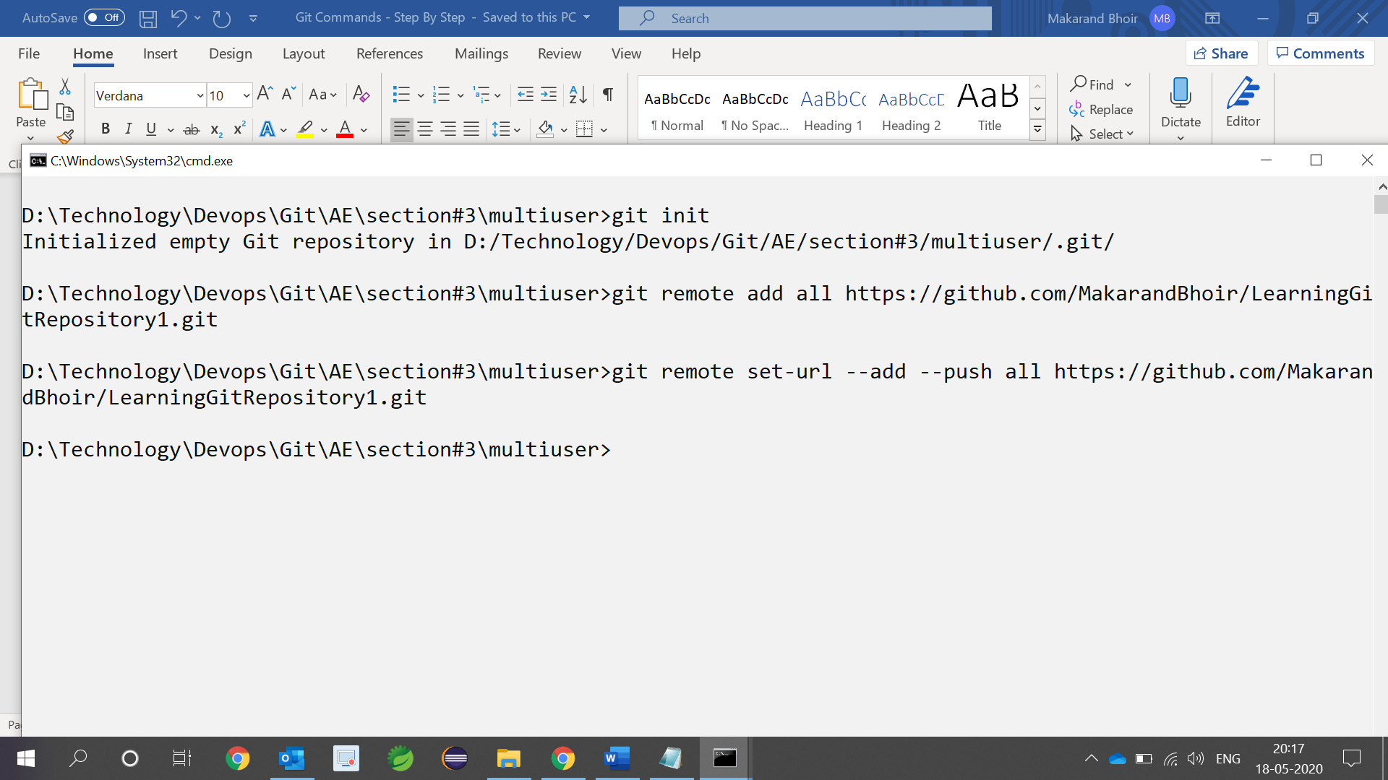

1. Add another git URL as push URL

git remote set-url --add --push all <https://github.com/MakarandBhoir/LearningGitRepository2.git>

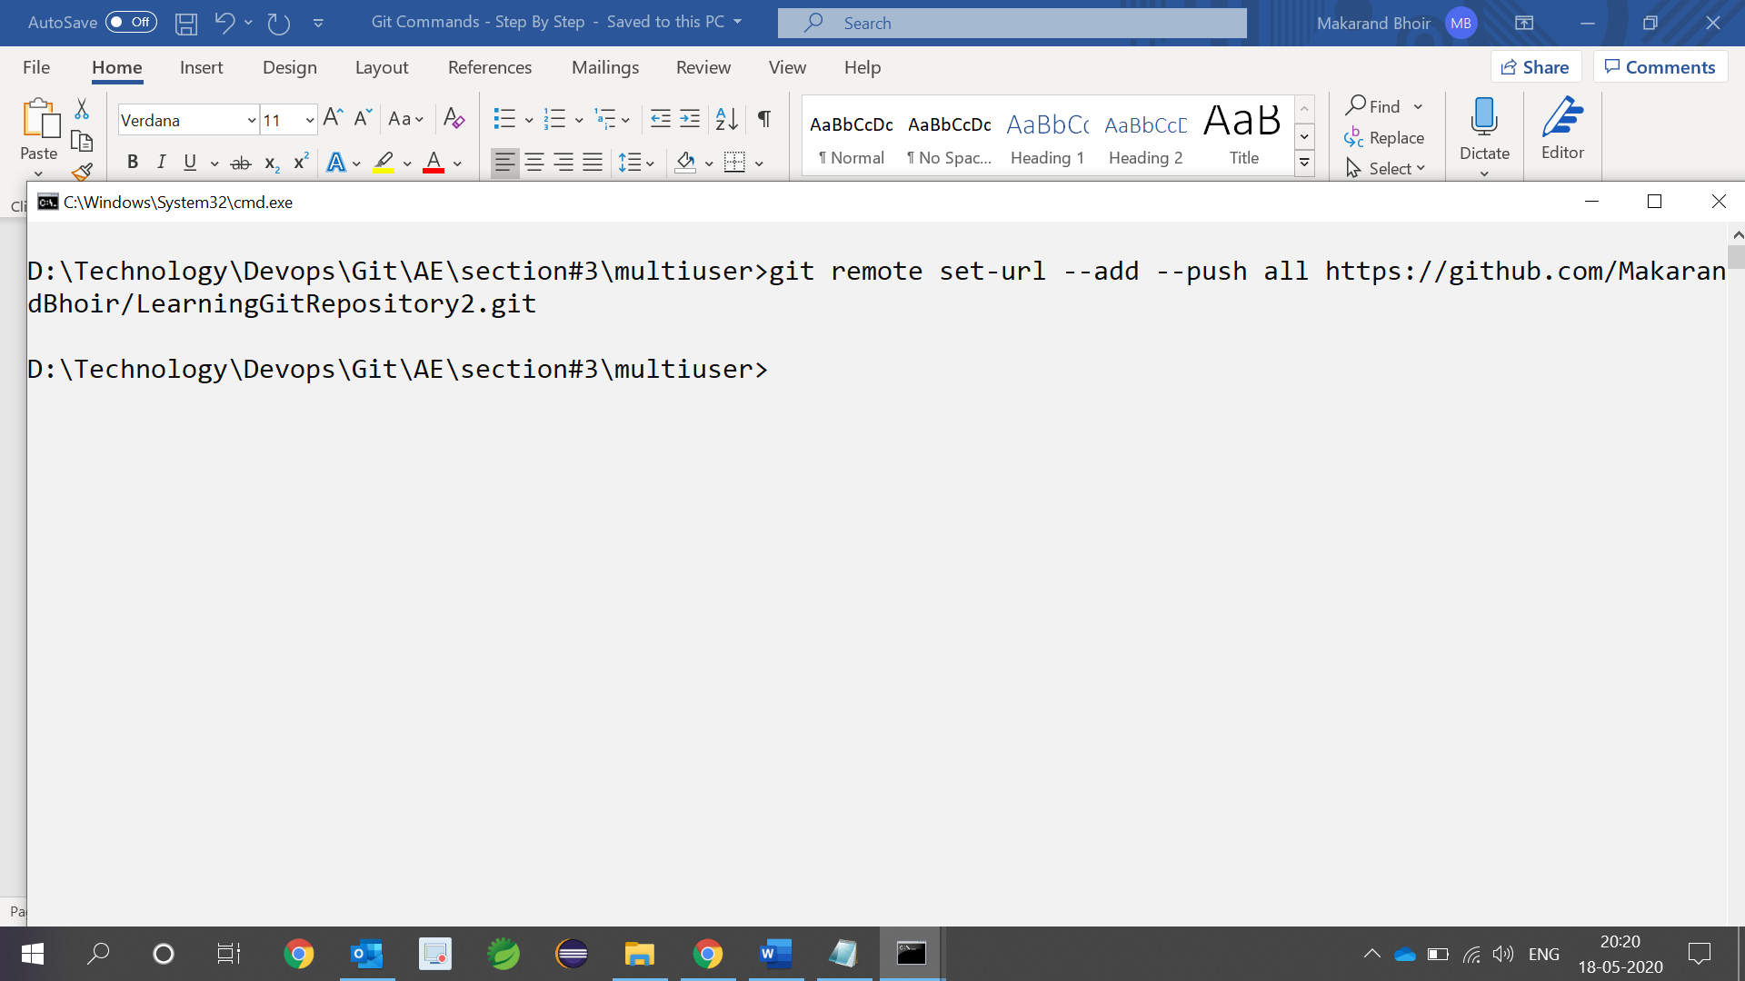

1. Add new file called as file.txt

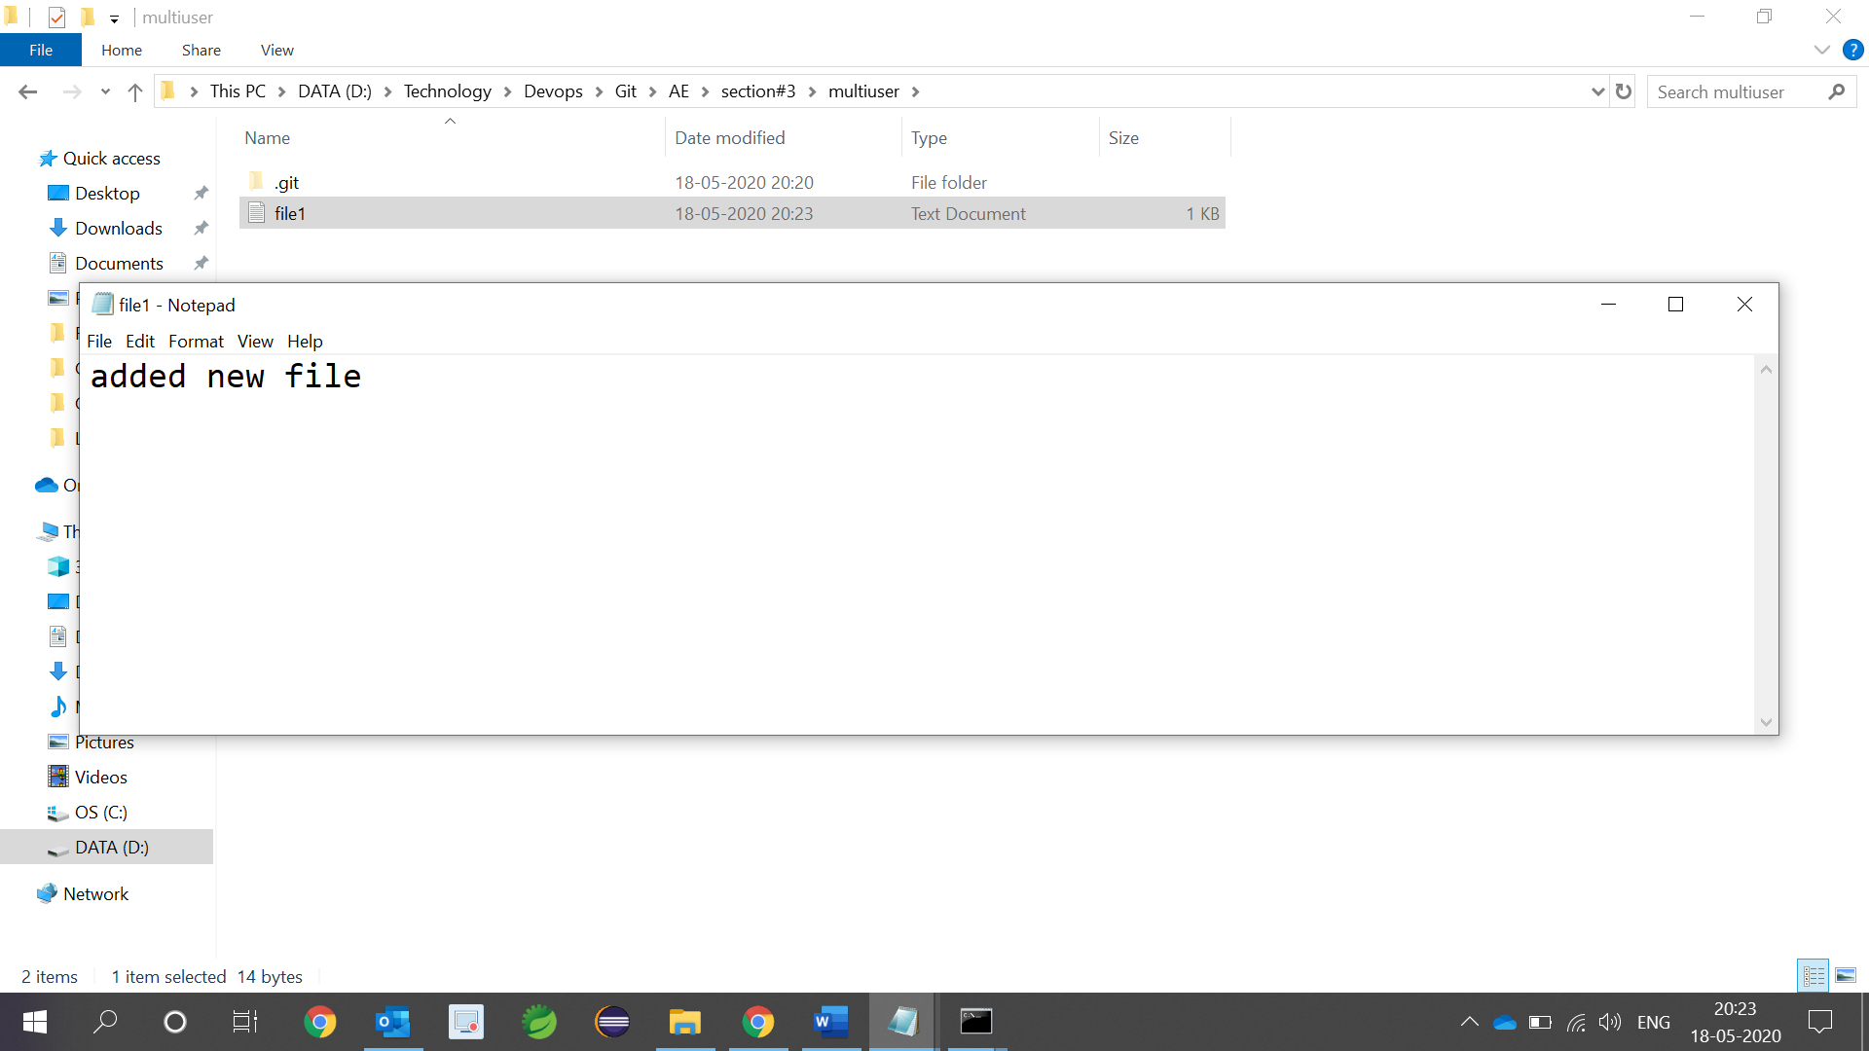

1. Pull the contains of remote using (git pull all master)

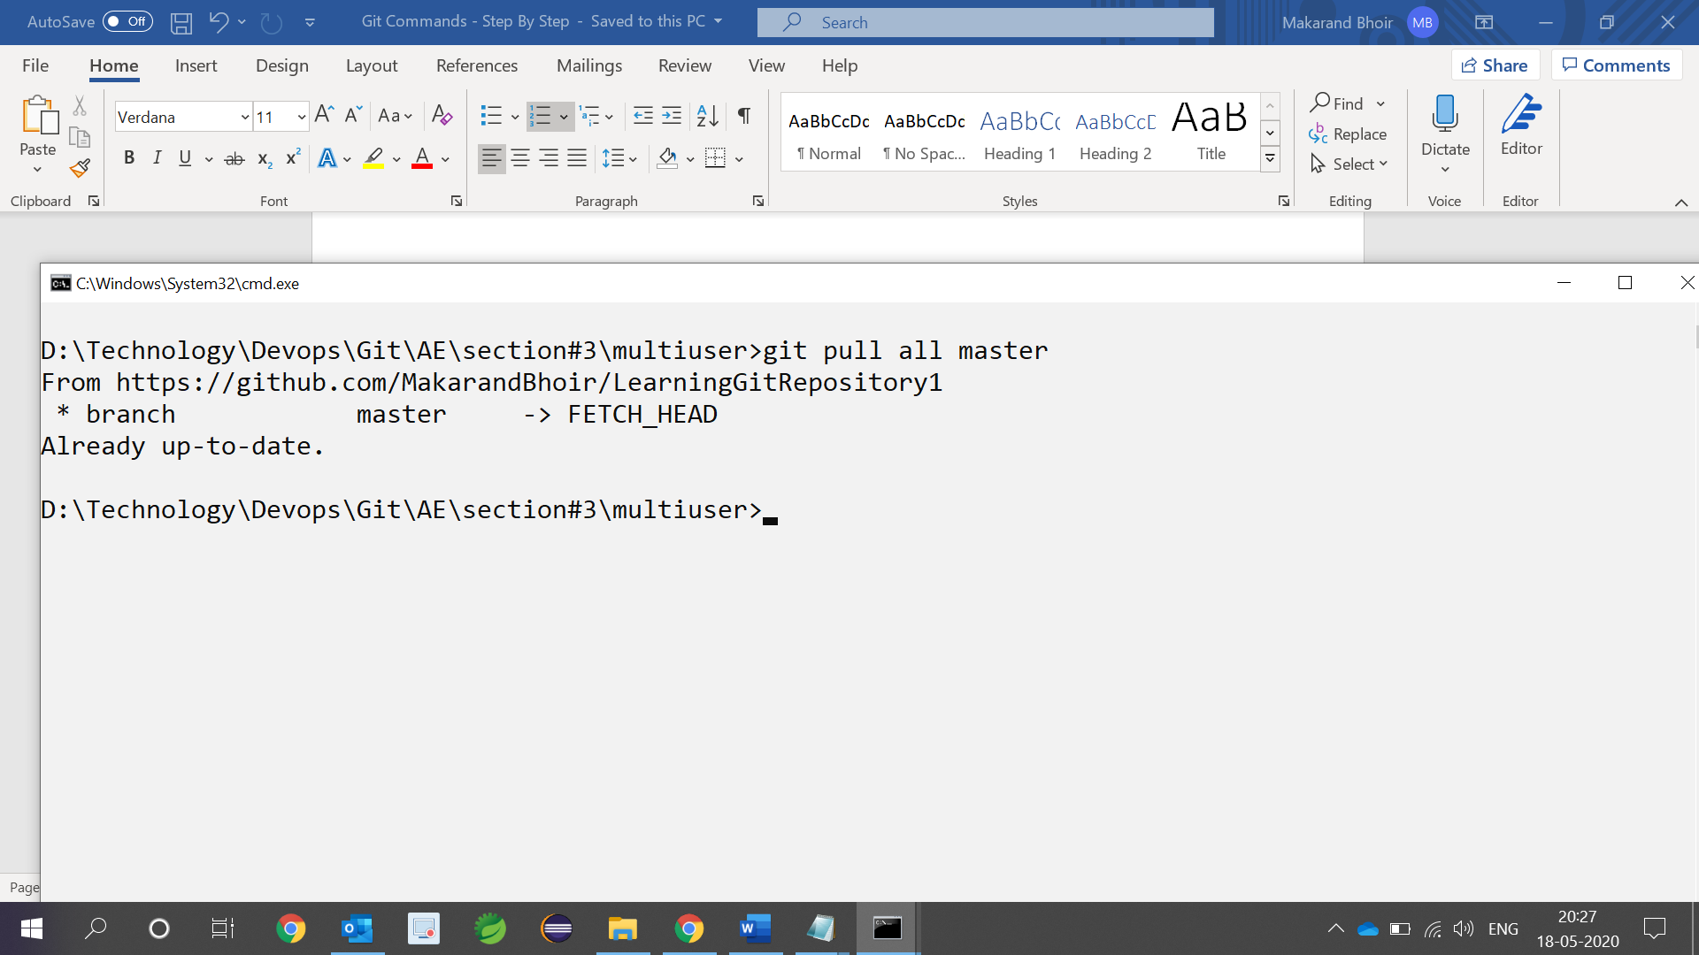

1. Add file to staging area and local repository

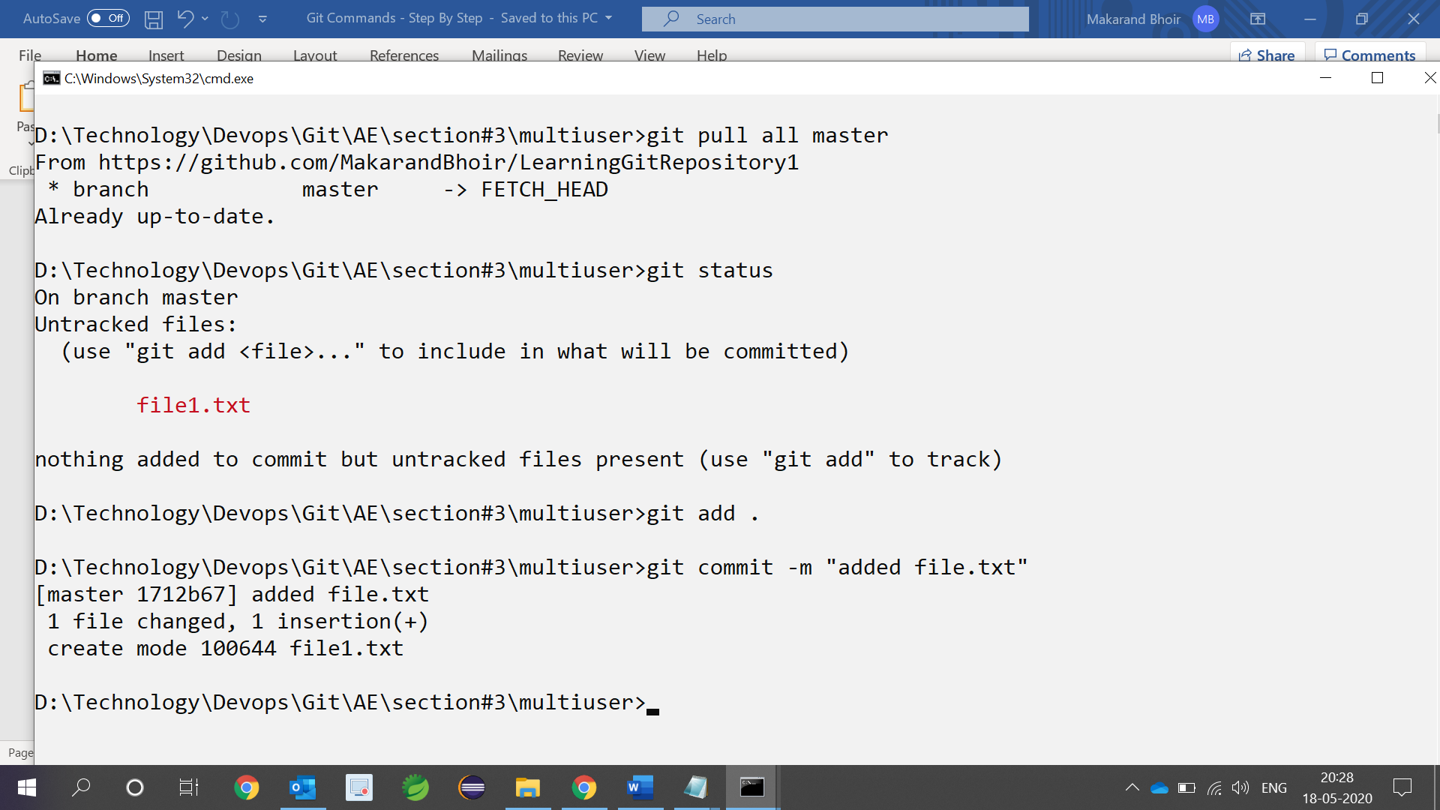

1. Push it to remote repository. So you should able to see file in both repository

